**FSN21218P: Analysis of Foodborne Pathogens**

**Objectives:**

This course will expose learners to

* Techniques of isolating bacteria and identifying bacteria;
* Methods of antibiotic sensitivity testing and viable microbial count in food.

**Learning Outcomes:**

Upon completion of this course, the learners would be able to

* Isolate and identify bacteria;
* Test antibiotics sensitivity against pathogens;
* Count viable microbes in food.

**Content:**

1. Aseptic culture technique

2. Method of isolation of pure culture

3. Identification of bacteria by Gram-staining

4. Antibiotics sensitivity testing

5. Isolation and identification of common food borne pathogens.

6. Determination of number of viable microorganisms in food sample.

7. Microbial testing of water

Introduction

Microbiology is the branch of biology that deals with the study of microorganisms, which are microscopic organisms such as bacteria, viruses, fungi, Achaea, and protists.Different kind of live microscopic organism are discussed in microbiology. Living organism are divided into 5 kingdoms on the basis of complexity of cell, complexity of organism, mode of nutrition. From which bacteria, protozoa, fungi and algae are commonly discussed in microbiology.

1. complexity of cell: Prokaryotes and Eukaryotes
2. complexity of organism: Unicellular, Multicellular
3. Mode of Nutrition: Autotrophic (photosynthesis) plant, saprophytic (absorption form dead body) fungus, heterotrophic (invective) Animal.

Cell wall present

Can’t perform photosynthesis

Cell wall present

Can perform photosynthesis

No cell wall

No organized nucleus

Eukaryotes other than fungi, algae, animalia

**Common microorganism responsible for food spoilage:**

* **Bacteria:**
* *Gram-negative bacteria:* Pseudomonas, Salmonella, Escherichia coli (E. coli)
* *Gram-positive bacteria:* Bacillus, Clostridium, Lactobacillus
* **Molds:**
* *Aspergillus species:* A. flavus, A. niger
* *Penicillium species:* P. roqueforti, P. camemberti
* *Rhizopus species:* R. stolonifer
* **Yeasts:**

1. *Saccharomyces cerevisiae*
2. *Candida species:* C. albicans, C. tropicalis

**Microbiology Lab equipment:**

1. Microscope
2. Incubator
3. Autoclave
4. Centrifuge
5. Biosafety Cabinet
6. Sprit lamp/ Bunsen Burner
7. pH Meter
8. Petri Dishes
9. Inoculation Loop
10. Micropipettes
11. Microbial Identification Systems
12. PCR Machine (Thermal Cycler)
13. Gel Electrophoresis Equipment
14. Microbial Fermenters
15. Different kind of media ingredients

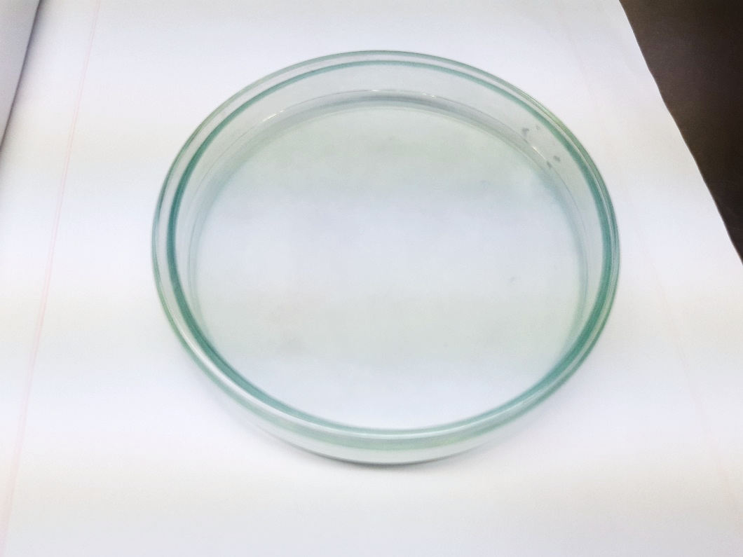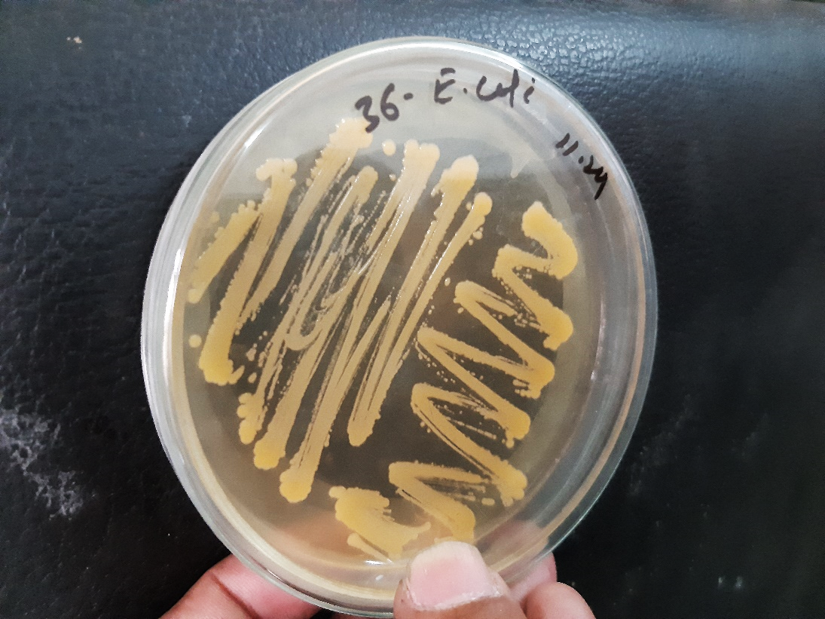

Petri dishes (Used for culturing and isolating microorganisms on solid media)

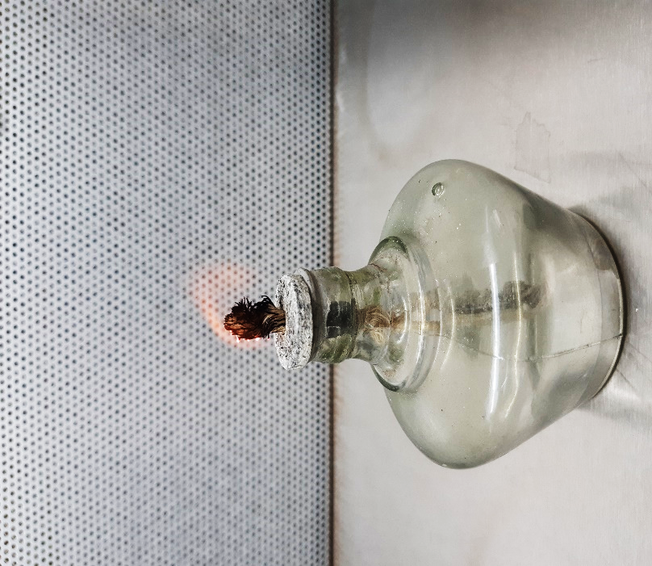 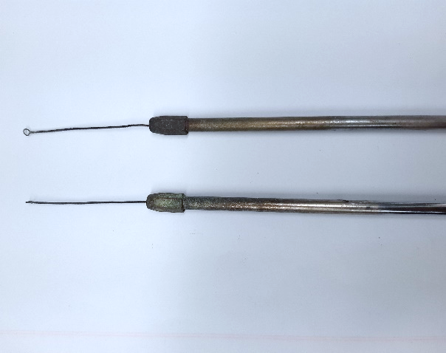

Inoculation loop (Used for transferring and streaking microorganisms onto culture media)

Spirit lamp (Used for sterilizing tools and the opening of culture tubes and petri dishes by flaming)

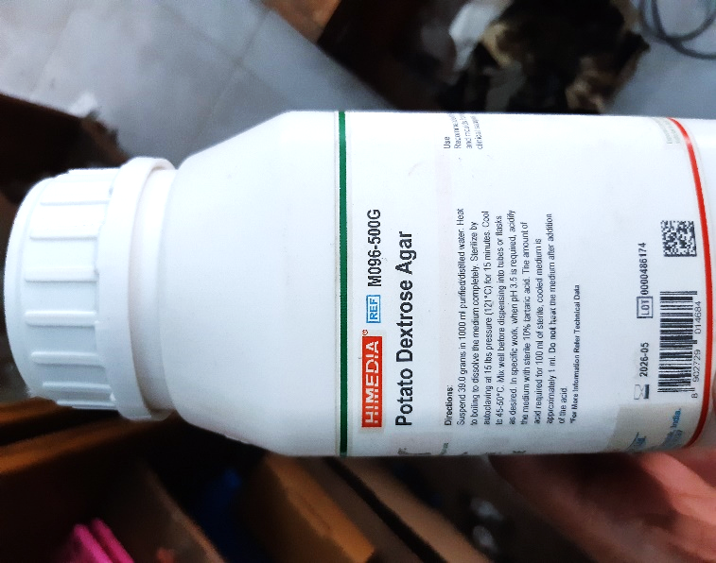 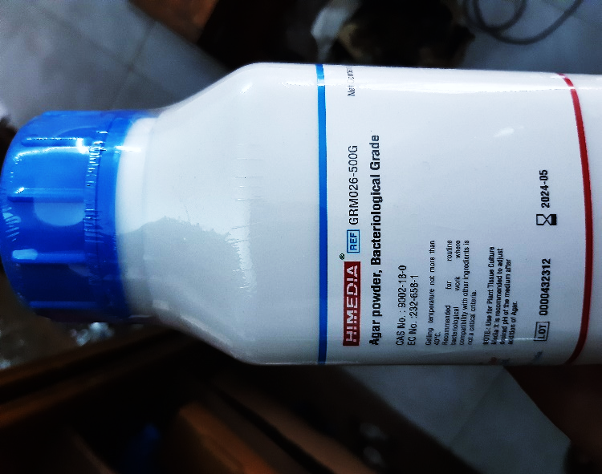

Media ingredients

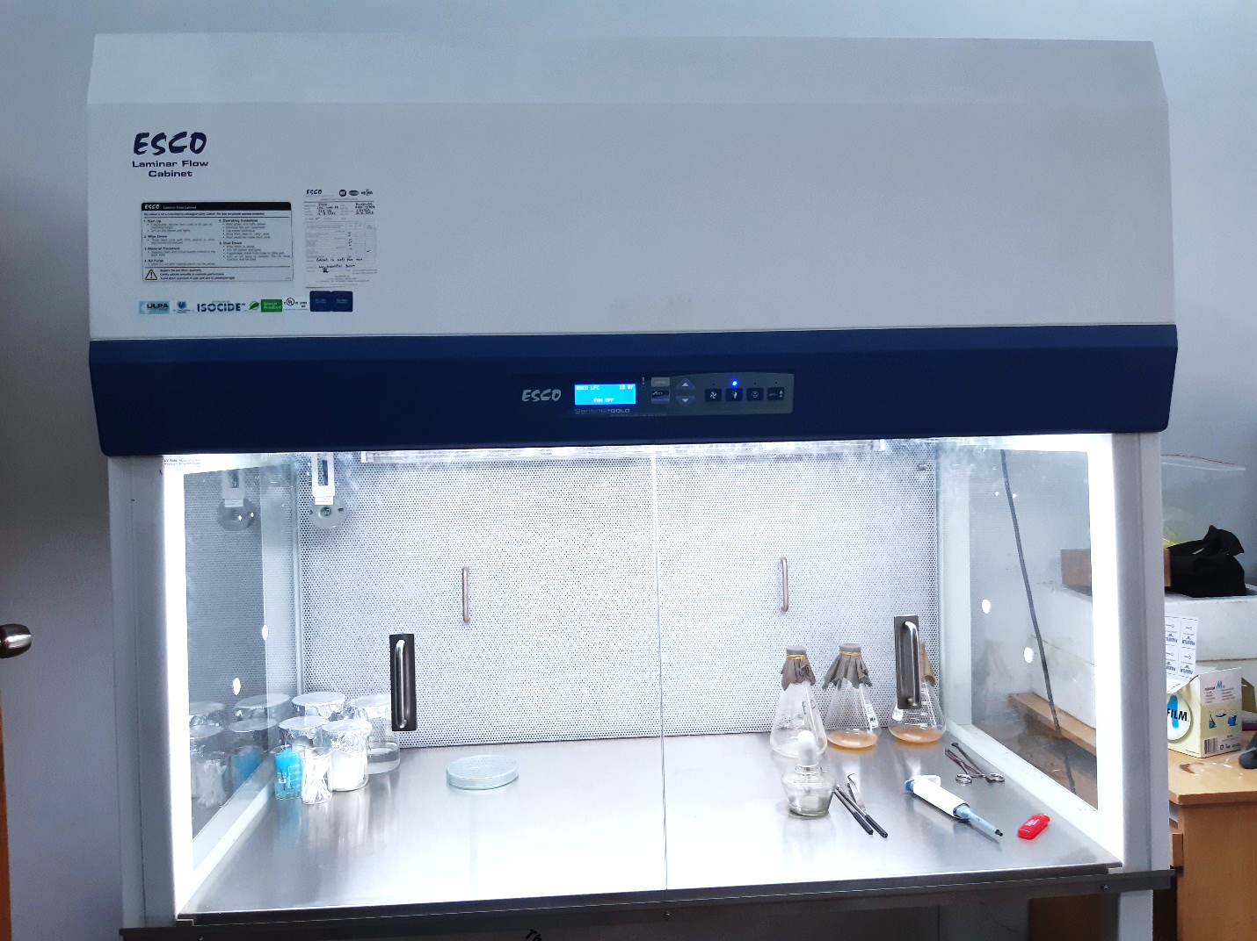

Biosafety Cabinet (Provides a sterile and enclosed environment for handling potentially hazardous microorganisms)

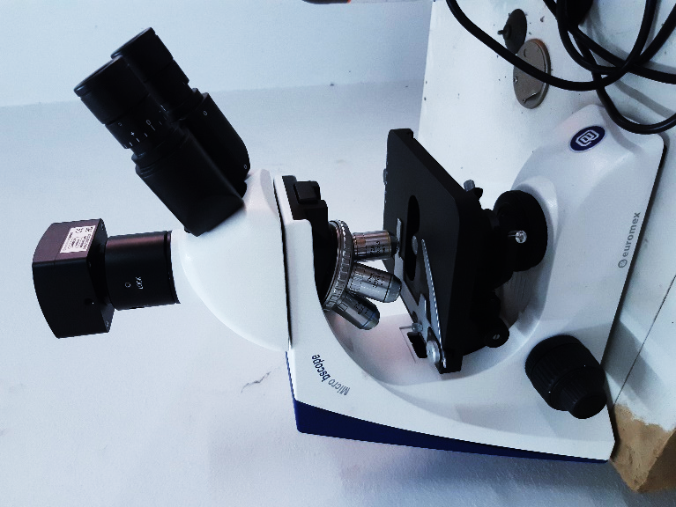

Microscope

Used for observing small specimens or cells at high magnification

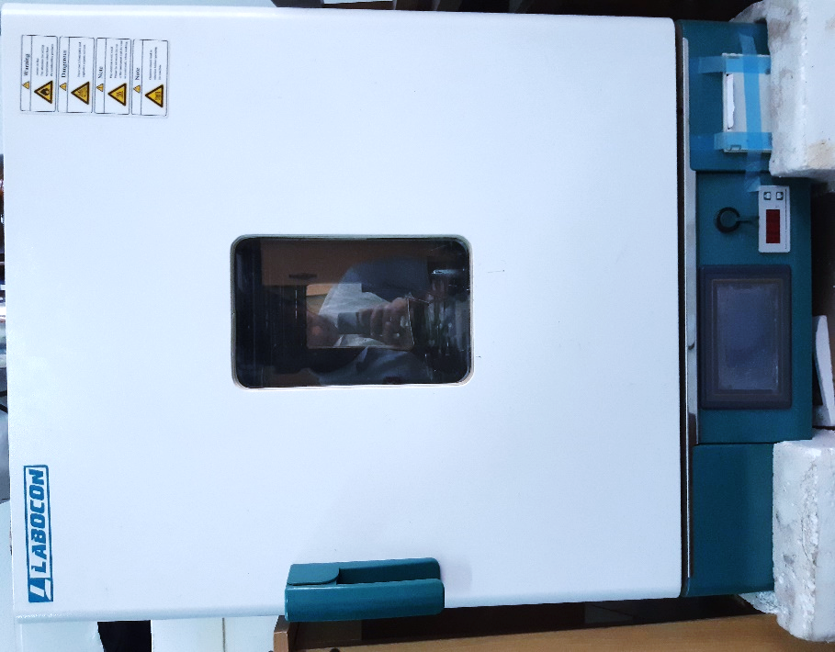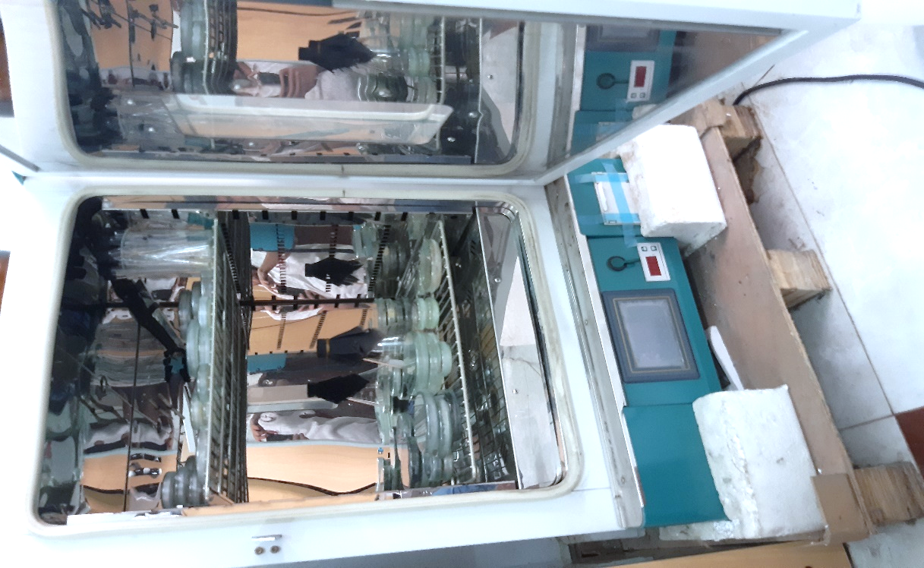

Incubator (Maintain controlled temperature and humidity for the cultivation and growth of microorganisms)

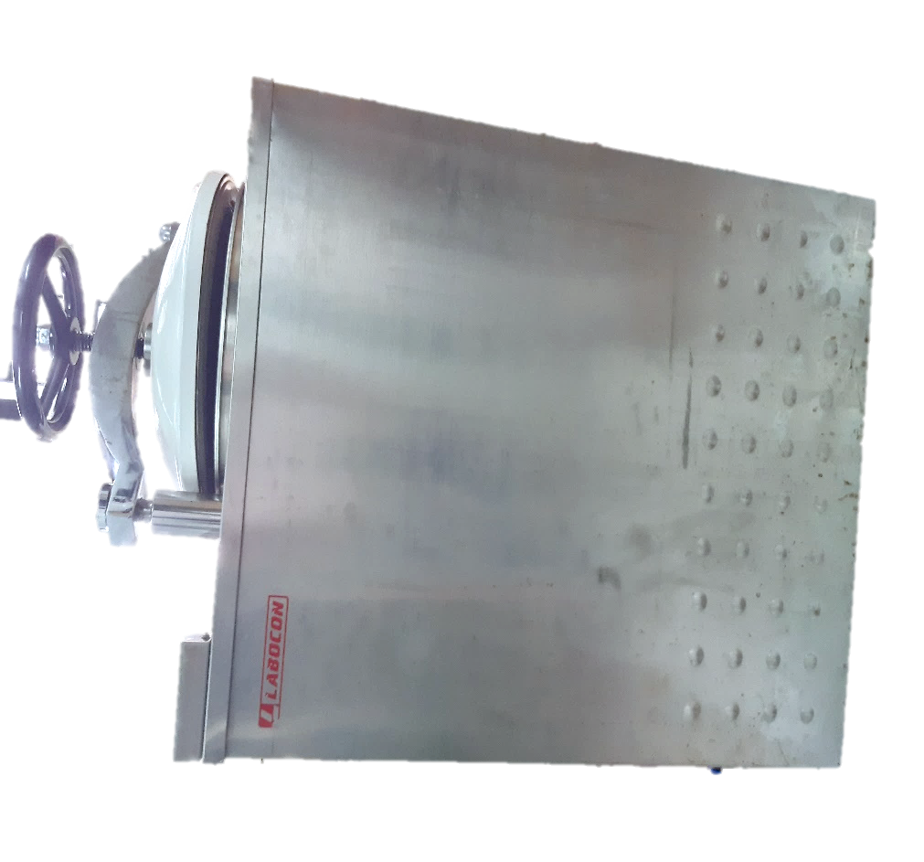

Autoclave

Sterilization equipment that uses high-pressure steam to kill bacteria, viruses, fungi, and spores on lab equipment and media

Culture Media

The food materials on which the organism is grown is known as culture medium and the growth of organism is known as culture. Different microorganisms require different nutrient materials. Thus, culture media vary in form and composition, depending upon the species to be cultivated.

* **Basic Requirements of Culture Medium**
* Energy source
* Carbon source
* Nitrogen source
* Salts
* Adequate oxidation
* Growth factors
* **Common Ingredients of Culture Media**

1. **Water**: Essential for existence of living cells.
2. **Peptone**: Obtained from meat, casein fibrin or soya flour. Acts as nitrogen source, carbon source, buffers
3. **Meat Extract**: Contains protein degradation products, carbohydrates. Source of growth factors (Vitamin B), inorganic salts etc.
4. **Yeast Extract**: Contains proteins, amino acids, growth factors (Vitamin B), Carbohydrates and inorganic salts like potassium and phosphates.
5. **Electrolyte**: Mainly used are sodium chloride or other electrolytes. Maintain the osmotic pressure
6. **Agar**: Dried mucilaginous substance obtained from gelidium and other algae; contains mainly long chain polysaccharides, protein like material and inorganic salts. Functions: it melts at 98 $℃$ and solidifies at 42 $℃$, hence used as solidifying agent.
7. **Fermentable** **Compounds**: Mainly used are sugars, alcohols etc. act as source of energy,
8. **Buffers**: Carbonates and phosphates are used as buffer to resist change in pH of the medium.

* **Types of Media**

Based on consistency culture media can be classified as:

* 1. **Liquid Media or Broth:** No solidifying agents (e.g. agar) is added while preparing the medium. The most commonly used non-synthetic liquid media are nutrient broth, peptone solution, milk, blood, serum etc. Used for obtaining bacterial growth from blood or water when large volumes have to be tested.
  2. **Semi-Solid Media:** It is prepared by adding small amount of agar (0.5%) or gelatin. Agar forms a colloidal solution in hot water and sets in the form of a jelly when cool. This type of medium can be used to study bacterial motility
  3. **Solid Media:** It is prepared by adding 2% or 1% gelatin. It's used for colony characterization, colony identification, etc. e.g. Agar plates, slants, deeps.

Based on purpose, culture media can be classified as:

1. **Simple Media:** General-purpose medium used for the cultivation of a wide variety of microorganisms. E.g. Nutrient broth, nutrient agar etc.
2. **Enriched Media:** Contains additional nutrients to support the growth of fastidious organisms. In these media, substances like blood, serum or egg are added. E.g. Blood agar, chocolate agar etc.
3. **Selective Media:** Contains inhibitors to select for the growth of specific groups of microorganisms. E.g. MacConkey agar, Mannitol Salt agar.
4. **Differential Media:** Allows for the differentiation of microorganisms based on their biochemical characteristics. E.g. Blood agar (hemolysis patterns), EMB agar (lactose fermentation).

* **Plating techniques**

The common plating techniques employed in microbiology are Streak Plate Method, Spread Plate Method and Pour Plate Method.

1. **Streak Plate Method**

This method is routinely employed for the isolation of bacteria in pure culture. In this method a sterilized inoculating loop is dipped into a suitable diluted suspension of microorganisms which is then streaked on the surface of an already solidified agar plate to make a series of parallel, non-overlapping streaks.

The main objective of the streak plate method is to produce well separated colonies of bacteria from concentrated suspensions of cells.

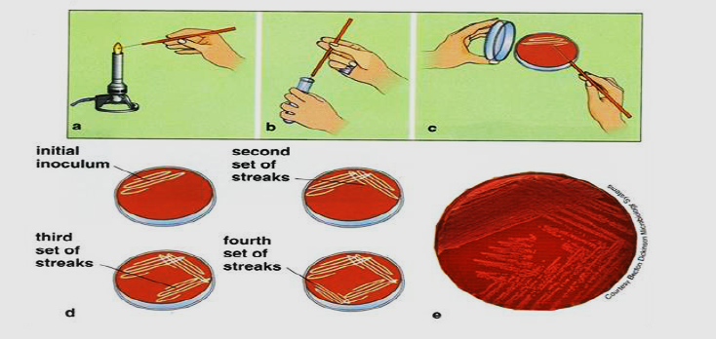

1. **Spread Plate Method**

The spread plate technique is used for the separation of a dilute, mixed population of the microorganisms so that individual colonies can be isolated. In this technique, a small volume of dilute microbial mixture is transferred to the center of an agar plate and spread evenly over the surface. The dispersed cells will develop into isolated colonies. Because the number of colonies will be equal to the number of viable organisms in the sample spread plates can be used to count the microbial population.

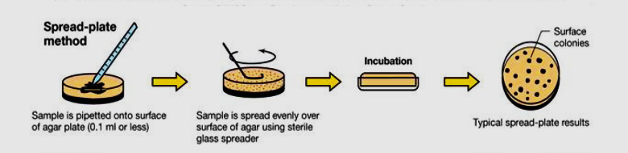

1. **Pour Plate Method**

In pour plate method, successive dilutions of the inoculum (serially diluting the original specimen) are added into sterile petri plate to which is poured melted and cooled (420C - 450C) agar medium and thoroughly mixed by rotating the plates which is then allowed to solidify. After incubation, the plates are examined for the presence of individual colonies. The pure colonies may be isolated and transferred into test tube culture media for making pure cultures. This technique is employed to estimate the viable bacterial count in a suspension.

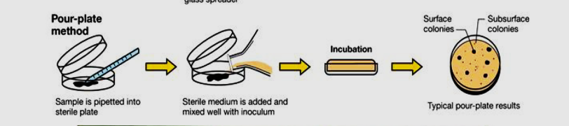

Aseptic culture technique

Aseptic culture technique is a set of practices used in microbiology and cell culture to prevent the contamination of cultures with unwanted microorganisms. The goal is to maintain a sterile environment and ensure the growth of only the desired microorganisms or cells. This technique is crucial in various fields, including microbiology, biotechnology, and medical research.

Here are some key principles and practices of aseptic culture technique:

1. **Personal hygiene:** Before entering the laboratory, practitioners should wash their hands thoroughly and wear appropriate protective clothing, such as lab coats, gloves, and, if necessary, masks.
2. **Work in a sterile environment:** All work is conducted within a laminar flow hood or a sterile workspace to minimize the risk of airborne contamination.
3. **Disinfection of surfaces and equipment:** Before starting any work, surfaces, and equipment are sterilized using disinfectants (70% ethanol). This includes workbenches, pipettes, and other tools.
4. **Flame sterilization:** Certain tools, such as inoculating loops or needles, are often sterilized using an open flame. The metal part of the tool is passed through the flame to kill any microorganisms present.
5. **Use of sterile techniques:** All materials, including media, culture vessels, and instruments, must be sterile. Sterile techniques involve careful handling of materials to avoid contamination. For example, pipettes are used to transfer liquids without exposing them to the surrounding air.
6. **Minimize exposure:** Cultures are opened and manipulated in a way that minimizes their exposure to the air and other potential sources of contamination. Lids are quickly removed and replaced, and tubes or plates are only opened when necessary.
7. **Proper disposal:** Used materials and cultures are disposed of properly to prevent the spread of contaminants. This may involve autoclaving waste before disposal.
8. **Regular monitoring:** Cultures are regularly checked for signs of contamination, such as changes in color, odor, or the appearance of unexpected growth.

Aseptic culture technique is fundamental in ensuring the success and reliability of experiments involving microorganisms or cells. It is essential for obtaining accurate results in microbiological research, clinical diagnostics, and industrial applications.

1. **Aseptic culture technique**

**Materials required:**

1. Distilled water
2. Conical flask
3. Measuring cylinder
4. Mular-Hilton agar media
5. Sprit lamp
6. Lighter
7. Inoculation loop
8. Petri dish
9. Disinfectant (70% Ethanol)

**Procedure**:

1. **Personal hygiene:** Before entering the laboratory, practitioners should wash their hands thoroughly and wear appropriate protective clothing, such as lab coats, gloves, and, if necessary, masks.
2. **Preparation of culture media:** Take weight of muller-hinton agar media ina conical flask and mix with distilled water following the label on media container.
3. **Sterilization**: Sterile the media and petri dishes by autoclaving at 121 $℃$ and 100KPa pressure for 15 minutes.
4. **Disinfecting workspace:**

* Before starting any work, sanitize your hand using disinfectant.
* Use 70% ethanol to sanitize your hands and to clean the biosafety cabinet's floor. After proper cleaning, close the cabinet’s door and turn on the UV lamp to kill any existing microorganisms.
* After ten minutes, turn off the UV lamp and open the door. Turn on the fan, in order to prevent microorganisms from entering into the biosafety cabinet.
* Then sterilize biosafety cabinet’s surfaces, and equipment using disinfectants (70% ethanol). This includes workbenches, pipettes, and other tools.

1. After sterilization is complete, take out media and equipment and keep them in the biosafety cabinet.
2. First, open the lid of petri dish for drying. Then, pour molten media to dry petri dish. Close petri dishes with lid after the media is solidified.
3. Burn the top portion of inoculation loop over the lamp flame, then cool it by drowning it into the media.
4. Touch the inoculation loop onto the bacteria of another culture media and spread it into new media.
5. Seal the petri dish using paraflim and incubate at 37 $℃$ for 24 hour.

Spread plate technique for colony counting

The spread plate technique is a common method used in microbiology for isolating and quantifying microorganisms in a sample. This technique is particularly useful for determining the viable cell count (number of live cells) in a liquid sample. Colony counting is often performed on solid agar medium using the spread plate technique.

**Materials and Equipment:**

1. Agar plates containing a suitable growth medium
2. Sterile pipettes or micropipettes
3. Sterile spreader or glass rod
4. Sterile distilled water or saline solution
5. Bunsen burner or alcohol burner
6. Inoculating loop or sterile pipette tips
7. Microbial sample to be analyzed

**Procedure:**

1. **Prepare Agar Plates:**

* Take weight of agar media and mix with distilled water following the label on media container.
* Sterile the media and petri dishes by autoclaving at 121 $℃$ and 100KPa pressure for 15 minutes
* Pour the hot media in sterile petri dishes aseptically inside biosafety cabinet and allow it to solidify.

1. **Label the Plates:**

* Label the bottom of each agar plate with the necessary information, such as the date, sample ID, and dilution factor.

1. **Dilution of the Sample:**

* If the sample is expected to have a high microbial count, perform serial dilutions by transferring known volumes of the sample into tubes containing sterile diluent (e.g., saline or sterile water). Mix the dilutions thoroughly.

1. **Inoculation:**

* Clean the biosafety cabinet properly with disinfectant (70% ethanol)
* Sterilize the spreading device (spreader or glass rod) by spraying 70% ethanol and flaming it with the Bunsen burner.
* Take a small volume (usually 0.1 mL) of the diluted sample using a sterile pipette or inoculating loop.
* Spread the sample evenly over the surface of the solid agar medium by gently moving the spreader or glass rod back and forth.

1. **Incubation:**

* Allow the agar plates to dry for a few minutes before placing them in an incubator.
* Incubate the plates at the appropriate temperature and conditions for the microorganisms being analyzed.

1. **Colonies Development:**

* After incubation (usually 24-48 hours), colonies will appear on the agar surface.
* Each colony arises from a single viable cell present in the original sample.

1. **Colony Counting:**

* Use a colony counter or manual counting method to count the individual colonies on the plates.
* Report the results as colony-forming units per milliliter (CFU/mL) based on the dilution factor.

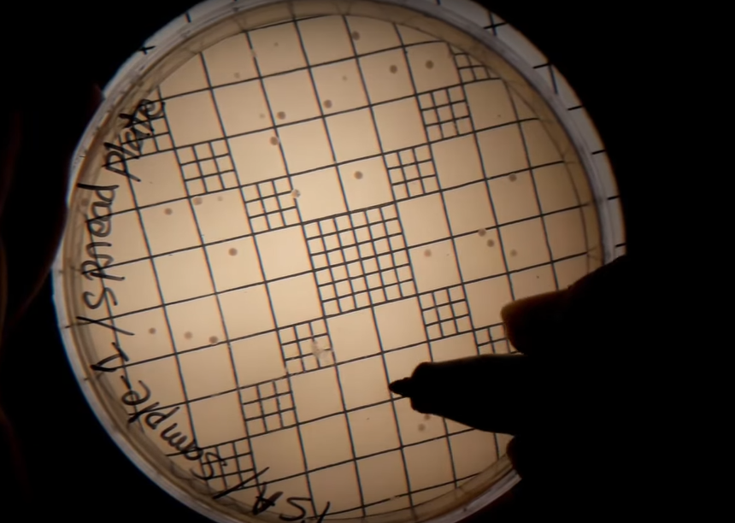

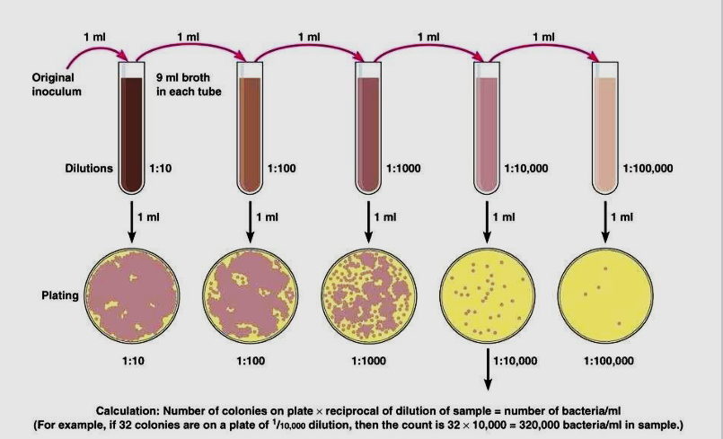

**Calculation**: Number of colonies on plate $×$ reciprocal of dilution of sample = number of bacteria/ ml

(For example, if 32 colonies are on a plate of 1/10,000 dilution, then the count is 32 $×$ 10,000 = 32,0000 bacteria/ ml in sample.

Isolating a pure culture

Isolating a pure culture involves separating a single species of microorganism from a mixed culture, allowing researchers to study it in a controlled environment. The streak plate method is a commonly used technique for isolating pure cultures.

**Materials required:**

1. Incubator
2. Biosafety Cabinet
3. Sprit lamp/ Bunsen Burner
4. Petri Dishes
5. Inoculation Loop
6. Colony counter

**Procedure:** The process generally involves the following steps:

1. **Preparation of culture media:** Take weight of agar media and mix with distilled water following the label on media container. Sterile the media and petri dishes by autoclaving at 121 $℃$ and 100KPa pressure for 15 minutes.
2. Clean the biosafety cabinet properly with disinfectant. Pour the hot media in sterile petri dishes aseptically inside biosafety cabinet. Wait for few minutes allowing the agar media to cool and solidify then cover the dish with lid.
3. Sterile the loop by burning to red hot.
4. After cooling the inoculating loop pick up one loop full of bacterial culture from the culture plate and make a smear with the culture of a corner of the fresh plate.
5. Burn the loop to red hot again to make it sterile. Wait to cool the loop and start streaking in zigzag style on first quarter of the plate touching the smear.
6. Close the plate and burn the loop again as done previously. After burning cool the inoculation loop and again streak on second quarter on the plate.
7. Streak on the third and fourth quarter without burning the loop.
8. Finish the streaking and cover the newly inoculated plate with lid. Lebel the sample name, date and method.
9. **Incubation:** Invert the plate and incubate at 37 $℃$ for 24 hours.
10. After incubation take out the plate from the incubator, you can see many isolated bacterial colonies in third and fourth quarter area. These are pure colonies which we have got from test.
11. Pick an isolated colony from this plate and culture it in another fresh by streaking method to get a pure culture of the bacteria.

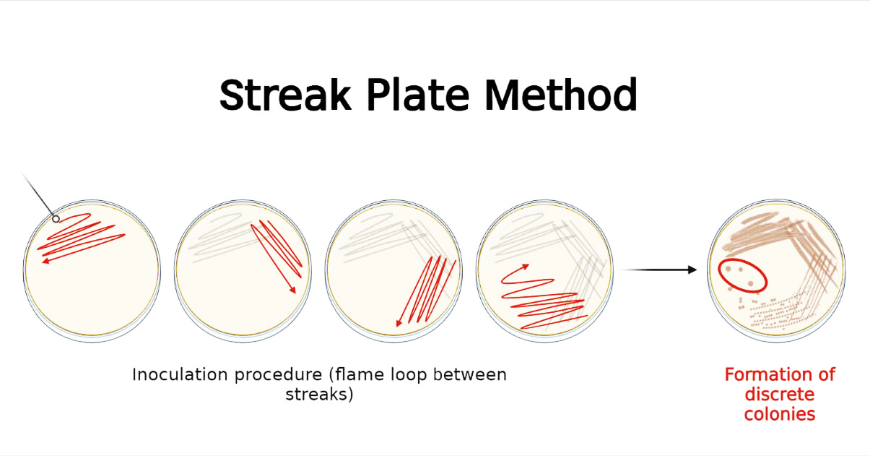

Microbial testing of water

Microbial testing of water is essential to assess its safety for various purposes, such as drinking, recreational activities, and industrial use. This testing involves the detection and quantification of microorganisms, including bacteria, viruses, and parasites, that may pose a threat to human health.

**Procedure:**

1. **Sample Collection:** Collect water samples aseptically in sterile containers to avoid contamination. Ensure proper sampling techniques are employed, and maintain representativeness of the water source.
2. **Transport and Storage:** Keep the water samples refrigerated during transportation to the laboratory. Analyze the samples promptly to preserve the viability of microbial populations.
3. **Plate Count Method:** Dilute the water samples appropriately to obtain countable colonies on agar plates. A known volume of the diluted sample is spread evenly on the surface of a solid agar medium in a Petri dish.
4. **Incubation:** Invert the Petri dishes and incubate them at the appropriate temperature for the desired incubation period. This allows microbial colonies to form.
5. **Colony Counting:** After incubation, count the visible colonies on the agar plates. Ensure accurate counting by avoiding overlapping or merged colonies.
6. **Calculation:** Calculate the microbial concentration in the original water sample using the formula:

Microbial Concentration (CFU/ml) = Number of Colonies Counted $×$ Dilution Factor

1. **Quality Control:** Implement quality control measures, including the use of control samples with known microbial concentrations, to validate the accuracy of the plate count method.
2. **Interpretation of Results:** Compare the microbial concentration obtained through plate counting with established water quality standards. Results guide decisions on water safety and potential corrective actions.

Antibiotic sensitivity testing

The disk diffusion method is a common technique used to assess the antibacterial activity of a substance, such as an antibiotic or plant extract. This method provides a qualitative measure of the susceptibility of bacteria to a specific compound.

**Materials and Equipment:**

1. Nutrient agar plates (or Mueller-Hinton agar for standardized testing)
2. Bacterial cultures (pure cultures of test organisms)
3. Sterile cotton bud or inoculating loops
4. Antibiotic disks or paper disks
5. Sterile forceps
6. A ruler or calipers
7. Incubator set to appropriate temperature (usually 35-37°C)
8. Sterile distilled water or saline (for suspension preparation)
9. Mueller-Hinton agar plates (for standardized testing)
10. Bunsen burner or alcohol burner
11. Disposal container for used materials

**Procedure:**

1. **Preparation of culture media:** Take weight of agar media and mix with distilled water following the label on media container. Sterile the media, petri dishes and cotton buds by autoclaving at 121 $℃$ and 100KPa pressure for 15 minutes.
2. Clean the biosafety cabinet properly with disinfectant. Pour the hot media in sterile petri dishes aseptically inside biosafety cabinet. Wait for few minutes allowing the agar media to cool and solidify then cover the dish with lid.
3. **Preparation of Inoculum:** Select the test bacterial strains. Prepare a bacterial suspension (using 0.9% NaCl) equivalent to a 0.5 McFarland standard. (0.063 absorbance at 600 nm wavelength).
4. **Inoculation of Agar Plates:** Using a sterile cotton bud, streak the bacterial suspension evenly over the surface of the agar plate. Allow the inoculum to dry for a few minutes.
5. **Placement of Disks:** Using sterile forceps, place the antibiotic disks onto the surface of the inoculated agar plates. Apply gentle pressure to ensure good contact between the disks and the agar surface.
6. **Incubation:** Incubate the plates at the appropriate temperature (usually 35-37°C) for 16-18 hours.
7. **Measurement of Zones of Inhibition:** After incubation, observe the plates for the presence of clear zones (areas without bacterial growth) around the disks. Measure the diameter of each zone of inhibition using a ruler or calipers.
8. **Interpretation:** Compare the diameter of the zones of inhibition with established standards or guidelines for specific antibiotics or substances. Larger zones generally indicate greater antibacterial activity.
9. **Controls:** Include positive controls with known susceptible bacteria and known antibiotic disks for validation. Include negative controls, such as disks with sterile water, to ensure that observed effects are due to the tested substance.

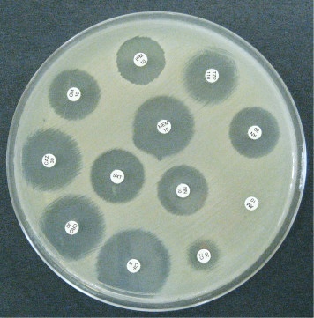

Antibiotic sensitivity test against bacteria

Isolation and Identification of Common Foodborne Pathogens

The isolation and identification of common foodborne pathogens is a crucial aspect of microbiology, particularly in ensuring the safety of food products. Below is a general outline for a laboratory protocol on the isolation and identification of common foodborne pathogens. Keep in mind that specific details and procedures may vary based on the pathogens of interest, the food matrix, and the resources available in your laboratory.

**Materials:**

* Various food samples (meat, dairy, vegetables, etc.)
* Sterile swabs or sampling tools
* Enrichment media (e.g., selective broth)
* Selective agar plates (e.g., Salmonella-Shigella agar, Eosin Methylene Blue agar)
* Biochemical test kits
* Microscope
* Incubator
* Sterile pipettes and pipette tips
* Personal Protective Equipment (PPE)

**Procedure:**

1. **Sample Collection:** Collect food samples aseptically, ensuring representative portions from different areas. Use sterile swabs or tools to sample the surfaces of the food items.
2. **Pre-enrichment:** 
   * Inoculate the collected samples into appropriate enrichment media to encourage the growth of target pathogens. This step helps revive stressed or injured bacteria.
   * Incubate the enrichment cultures according to specific pathogen requirements.
3. **Selective Plating:**
   * After enrichment, streak the culture onto selective agar plates specific for the target pathogens. Different media may be used for different pathogens (e.g., MacConkey agar for Enterobacteriaceae, Mannitol Salt agar for Staphylococcus aureus).
   * Incubate plates at appropriate temperatures and durations.
4. **Colonial Morphology:** Examine the colonies for characteristic morphology. Note color, size, shape, and any other distinguishing features.
5. **Biochemical Testing:**
   1. Perform biochemical tests on isolated colonies to identify the genus and species of the bacteria present. Common tests include:
      * Catalase test
      * Oxidase test
      * Gram staining
      * Triple Sugar Iron (TSI) agar test
6. **Confirmation Tests:**
   1. Use specific identification methods for common foodborne pathogens, such as:
      * Polymerase Chain Reaction (PCR)
      * Serological tests
      * Antibiotic sensitivity testing

# Identification of salmonella from food sample

**Part-1:** Primary identification using selective media.

**Culture Media preparation**

**Buffered Peptone Water (BPW)**

1. Dissolve 25.5g Buffered Peptone Water powder into 1000ml Distilled Water.
2. Autoclave at 1210C temperature and 15 lbs. pressure for 15 minutes.

**Rappaport Vassiliadis Soya (RVS) Broth**

1. Dissolve 2.71g RVS Broth powder into 100ml Distilled Water.
2. Heat to dissolve the medium completely and distribute 10ml into Glass Test Tubes.
3. Sterile by autoclaving at 115 ℃ and 15 lbs. pressure for 15 minutes.

**Sample preparation**

1. Take about 25g sample into a sterile bag and label the bag with sample name.
2. Take the sample in a biosafety cabinet.
3. Measure 225 ml buffered peptone water aseptically and pour it into the bag.
4. Shake the bag to mix the content, vortex the mixture to homogenize the sample for 15 sec.
5. Now incubate the mixture at 37 ℃ for 24h for non-selective enrichment.

**Procedure:**

1. We will use RSV broth for selective enrichment of salmonella.
2. Shake the bag to mix the culture properly and transfer 0.1 ml buffered peptone water enrichment culture into RSV broth and attach the cap loosely.
3. Then, vortex the test tube for 10 seconds and incubate broth at 41.5℃ for 24 h.
4. After incubation, take out RSV broth cultures and streak from RVS Enrichment on BSA Plate for Trial-1 and Trial-2 plates.
5. Streaking from RVS Enrichment on XLD Plate for Trial-I and Trial-2 plates.
6. Now incubate the inoculated XLD & BSA plates at 37℃ for 24.

**Observation:**

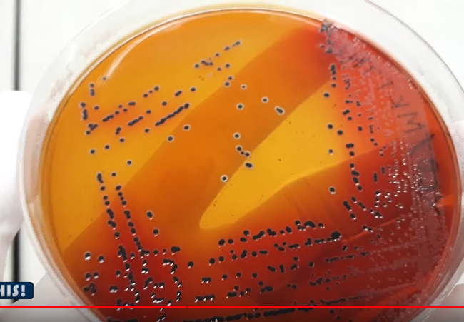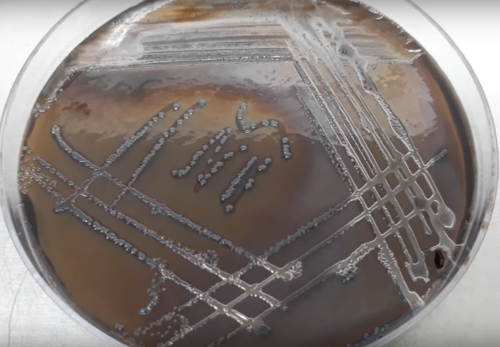

|  |  |
| --- | --- |
| *Black colonies on XLD plate are primarily considered as Salmonella spp.* | *Black to grey colonies turned the BSA media color into black. These black or grey colonies are primarily considered as salmonella spp.* |

**Part 2: Biochemical Identification**

**Required Medias**

1. Triple Sugar Iron (TSI) Agar
2. MR-VP Medium
3. Simmon Citrate Agar
4. LIM Medium
5. Urea Agar

**Reagents**

1. For Indole Test Kovacs Reagent: Commercially prepared Kovacs Reagent is Available
2. For MR Test Methyl Red Solution: Dissolve 1g Methyl Red Indicator Powder into 100ml Ethanol
3. For VP Test 1-Napthanol Solution: Dissolve 1.2g of 1-Napthanol Powder into 20ml Ethanol.
4. For VP Test Potassium Hydroxide Solution: Dissolve 20g of Potassium Hydroxide Pellets into 50ml Distilled Water.
5. For VP test Creatine Solution: Dissolve 0.5g Creatine Monohydrate into 100ml Distilled Water.

**Procedure**

1. Take 7 stoppered test tube with citrate agar, MR-VP medium, MIU agar, LIM medium, Urea agar and TSI agar.

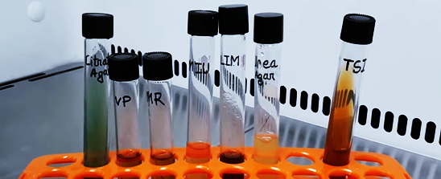

1. Inoculate the two MR-VP medium with the suspected Salmonella colony for MR test and VP test. Attach the cap and rotate the tube to mix the content.
2. 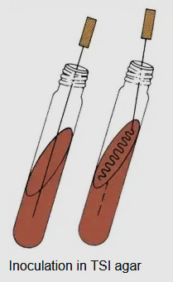Inoculate the slant & butt of TSI with the suspected Salmonella colony. Stub into the butt and then streak on the slant surface of TSI Agar then attach the cap.
3. Inoculate the slant & butt of Simmon citrate Agar with the suspected Salmonella colony. Stub into the butt and then streak on the slant surface.
4. Now stub into the MIU medium without disturbing the surrounding media for motility, indole and urea test.
5. Now stub into the LIM medium to inoculate it for lysin decarboxylation test.
6. Now stub into the Urea Agar medium to inoculate it for urea utilization test.
7. Loose the cap and incubate all of the inoculated tubes at 37°C for 24 hours.

**Observation:**

1. **TSI:** Black color butt is formed due to hydrogen sulfite formation and slant turned into red due to dextrose fermentation. The medium is lifted-up from the bottom due to the gas production.

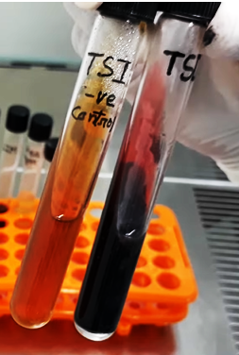

1. **LIM:** The media color is turned into purplish. So, the bacteria showed positive reaction for this test.

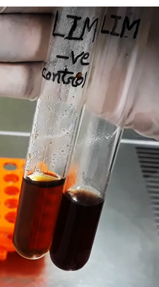

1. **SCA:** The media color is turned into blue from green. So, the bacteria is Citrate positive

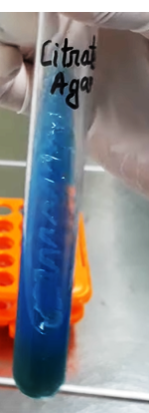

1. **MUI**: Media colour is not turned into pink. So, the bacteria is urea negative. Growth pattern shows the bacterial growth is spread out throughout the media outside of the stub-line. That's why the bacteria is motile. Now, add few drops of Kovacs reagent. No cherry ring is found indicating that the bacteria is indole negative

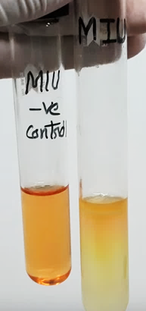

1. **Urea Agar:** No pink color is formed in the Urea Agar. So, the bacteria can't utilize Urea.

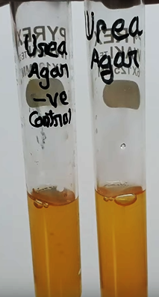

1. **MR:** Add few drops of methyl red solution into the MR tube. Red color development indicates that the bacteria is positive for MR test.

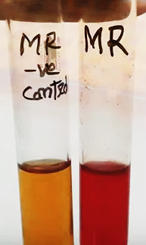

1. **VP:** Add 3 drops of creatine solution. Now, add 2 drops of 1-napthol and finally add 3 drops of potassium hydroxide solution. Close the tube with it's cap and shake slightly to mix the reagents. No pink or red color in 15 min indicates the bacteria is VP negative.

|  |  |  |  |  |  |  |  |  |  |
| --- | --- | --- | --- | --- | --- | --- | --- | --- | --- |
|  | TSI slant | H2S & Gas | Motility test | Indole test | Urea test | Lysine decarboxylase | Citrate Utilization | MR reaction | VP reaction |
| Typical salmonella spp. | Red | +VE | +VE | -VE | -VE | +VE | +VE | +VE | -VE |
| Suspected Bacteria | Red | +VE | +VE | -VE | -VE | +VE | +VE | +VE | -VE |